Footings 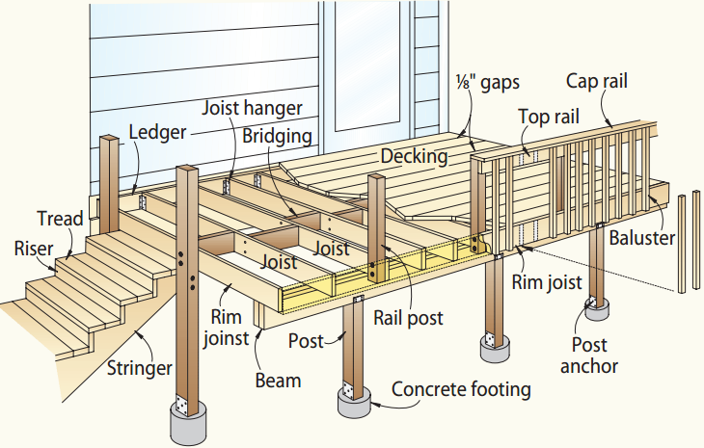
joist

The base of the footing must be at least 42” below finished grade (frost line). Footings supporting a 4 x 4 column must not be less than 6” diameter. Post footings supporting columns larger than 4 x 4 must be 8” diameter or larger. The bottom of post footings may be “belled” to achieve the desired minimum bearing area. *Please Note: Per New Germany’s Designated Building Official, Metro West Inspection Services: “Diamond pier footings will not be accepted without a project specific soil report from a licensed State of MN engineer.”

At least 2 business days before you dig…
Gopher State One Call
(651) 454-0002 - - or- - 811

DO YOU THINK YOU MIGHT ENCLOSE YOUR DECK IN THE FUTURE?
Deck plans are approved based on the assumption that the deck will be used only as a deck for the life of the structure. Because there are so many components that will vary by becoming a porch, it is important that you indicate this possibility on your plans. Your deck design should reflect the future loads (including the addition of a hot tub), meet setbacks and any other applicable rules.

MATERIALS
Fasteners
Nails and other hardware must be hot-dipped zinc-coated (galvanized), stainless steel or equivalent. Screws should be either hot-dipped galvanized or electroplated with a polymer coating. 12d nails are recommended on nominal 2-inch decking. 10d nails are recommended for 5/4 decking.
With lag screws, use a flat washer under the head. Use washers under the nut and head of machine bolts and just under the nut of carriage bolts.
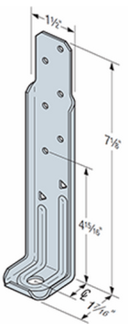
The Simpson Deck Tension Tie (DTT) Brackets are one example of lateral load bracing. Four of these per deck would provide the required lateral bracing to a rim or band joist (you would need to double-check with the manufacturer’s load table).

Lumber
All wood used in deck construction must be pressure-treated lumber or wood that is naturally resistant to decay such as redwood or cedar.
Wood used above ground, in contact with the ground, or below ground, requires different degrees of treatment. Check the labels of the material you are buying to determine where it can be used. Because some preservative treatments are very corrosive, make sure that any fasteners or metal connectors used in the construction of your deck are approved by the manufacturer for use with treated wood.
Simpson
DTT Bracket

Decking
Materials commonly used for decking include standard dimension lumber (either 2x4 or 2x6), radius-edged decking or a manufactured decking product. Radius-edged Patio Decking (5/4 decking) has been specifically developed for outdoor decks.
Redwood and cedar patio decking is intended to be used flat-wise in load-bearing applications where spans do not exceed 16” o.c. (12” o.c. when installed diagonally to joists). Southern pine decking may span 24” o.c. or 16” o.c. when installed diagonally to joists.

Manufactured decking (composite) may be used when approved by the building department.

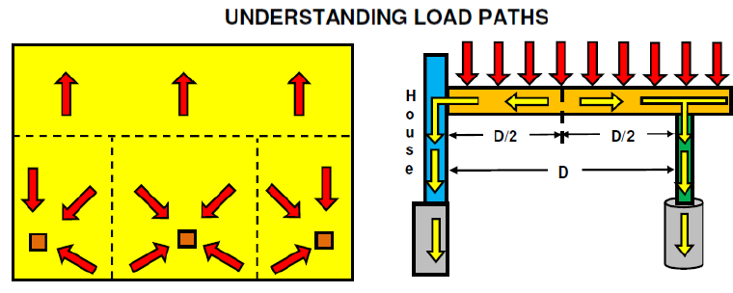

DECK FOOTING SIZES (1500 PSF SOILS) - **NOT FOR USE WITH HOT TUBS
Max. Area of Deck Supported  (Square Feet) | Footing Diameter Required  (Inches) | Max. Area of Deck Supported  (Square Feet) | Footing  Diameter Required  (Inches) | Max. Area of Deck Supported  (Square Feet) | Footing  Diameter Required  (Inches) | Max. Area of Deck Supported  (Square Feet) | Footing Diameter Required  (Inches)
10 | 8 | 23 | 12 | 41 | 16 | 65 | 20
13 | 9 | 27 | 13 | 47 | 17 | 72 | 21
16 | 10 | 32 | 14 | 53 | 18 | 79 | 22
19 | 11 | 36 | 15 | 59 | 19 | 86 | 23

HANDRAILS, STAIRS AND GUARDRAILS

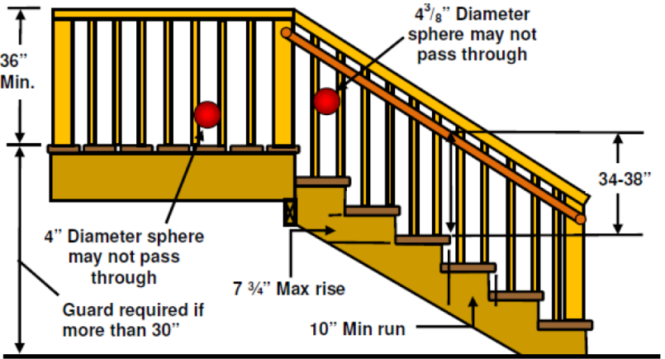
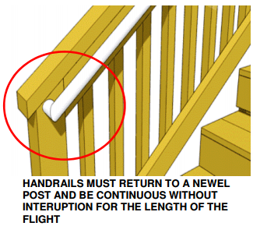

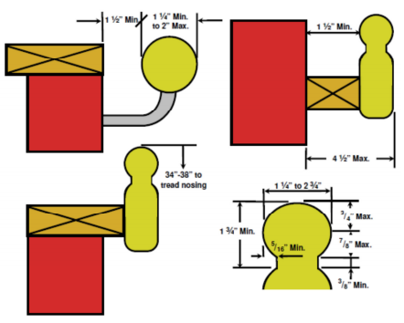

Decks and platforms are required to meet the land use requirements of our community’s zoning code. Zoning questions should be directed to our planning and zoning department. This is an important first step in the planning of any deck project.

PERMIT FEES
Permit fees are established by the city of New Germany. The plan review is done by the building official in order to spot potential problems or pitfalls that may arise. The official may make notes on the plan for your use. The plan review and inspections are done to provide a reasonable degree of review and observation so the project will be successful, safe, and long-lasting.
The building inspector will need an application for permit, site plan or survey (with specific setback information), and building plans. Examples of these are provided in the rest of this brochure. The inspector may inform you of potential problems or make suggestions. Safety will receive the greatest priority.

REQUIRED INSPECTIONS

- Footings: After the holes are dug, but PRIOR TO THE POURING OF CONCRETE.
- Framing: To be made after all framing, blocking, and bracing are in place and prior to covering the construction so it is accessible for inspection. This inspection can be completed at the time of the final inspection if all parts of the framing will be visible and accessible.
- Final: To be made upon completion of the deck and finish grading.
- Other inspections: In addition to the three inspections above, the inspector may make or require other code inspections, such as an electrical inspection, to ascertain compliance with the provisions of the code or to assist you with your questions or concerns during the construction process.

SETBACKS

Setbacks from property lines vary depending upon the zoning district your home is located in. Contact the Department of Building Safety or Planning Department for the requirements in your location. This is an important first step in the planning for any deck project.

GENERAL BUILDING CODE REQUIREMENTS

- Footings must extend to frost depth (if attached to the house).
- Decks need to be designed for a 40-pound per square foot live load and balconies to a 60 pound per square foot live load. Decks exposed to the weather must be constructed of approved wood with natural resistance to decay such as redwood, cedar or treated wood, or other material (composite plastics, etc.) WITH PRIOR APPROVAL OF THE BUILDING INSPECTOR.
- Pressure-Treated Wood - Recent changes have been made in the chemicals used in the manufacture of pressure-treated wood. Chromated copper arsenate, also known as CCA, is being phased out and the most common new treatments approved for outdoor use are Alkaline Copper Quaternary (ACQ) and Copper Azole. According to the lumber and fastener industry, the newer chemicals being used to treat the wood approved for outdoor use are considerably more corrosive than those previously treated with CCA and therefore require special fasteners, hangers, and greater care in the selection of materials that may come in contact with the wood. The fastener industry has indicated that some of the hangers and fasteners currently on the market may not perform with some of the new treatments. Designers, builders, and homeowners will need to pay particular attention to the grade marks on the lumber, and verify that proper hardware (hangers, nails, brackets) are appropriate with the particular treatment of the lumber. This not only applies to decks utilizing these products but sill plates and posts as well. The code references the American Wood Preservers Association (AWPA), which has published information on this issue. Particular attention should also be made to the manufacturer's installation instructions for the hardware. Questions should be directed to your wood and fastener supplier or your local Building Official.
- Columns and posts in contact with the ground or embedded in concrete, earth or masonry must be of special pressure treated wood approved for ground contact. Cedar or redwood posts need an 8 inch separation from the ground.
- All decks, balconies or porches, open sides of landings and stairs which are more than 30” above grade or a floor below must be protected by a guard not less than 36 inches in height. Open guard and stair railings require intermediate rails of an ornamental pattern such that a sphere 4 inches in diameter cannot pass through.
- If a stairway is to be provided, it must be not less than 36 inches in width. Stairways may be constructed having a 7 ¾ -inch maximum rise (height) and a 10-inch minimum run (length). The largest tread rise and tread run may not exceed the smallest corresponding tread rise or run by more than 3/8 inch. Stairway illumination is required by the code.

Handrails are required on all stairways having 4 or more risers. Handrails may not be less than 1 1/4” nor more than 2 5/8” in cross sectional area. The handrails must be graspable, continuous and uninterrupted. Top of handrail must be not less than 34 inches nor more than 38 inches above the nosing (front edge) of treads and they must be returned to a wall or post.
The electrical code requires overhead power lines to be located a minimum 10 feet above decks and platforms. Existing lines may need to be raised if a new deck is to be installed beneath them.
Outside meters, wells, and septic systems. When locating a deck care must be given to the location of existing gas and electric meters, wells, and septic systems. These may need to be relocated to allow for construction of the deck. Septic systems and wells may be difficult to relocate, requiring an alternative location for the deck. Prior to placement of any deck that will interfere with these devices, contact the building inspector.
Outside water meter readers. Prior to placement of any deck that will interfere with the operation or accessibility of the reader, contact your local Building Inspector or Water Department to obtain information and procedures on relocating these devices. Note: For specific code requirements, please contact us.

PLANS: SITE, FLOOR, and ELEVATION
The following shows the minimum detail expected so the permit process can proceed smoothly. TWO sets of each plan are required. Plans do not need to be professionally drawn. The application for permit can be filled out at the time you drop off your plans.

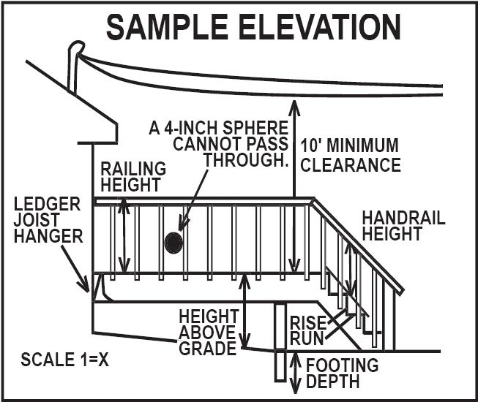 | ELEVATION PLAN:  - Height of structure from grade.  - Size and depth of footings.  - Guard height and spacing (if any).  - Stairway rise/run and handrail height (if any).  - Clearance of overhead wires (if applicable)
SURVEY OR SITE PLAN  - A Certificate of Survey or Site Plan drawn to scale indicating the lot dimensions, the location and size of the existing structure(s), and the location and a size of the proposed structure.  - Indicate the setbacks from property lines of the existing and proposed structure(s). Include septic system area and wells if applicable. | 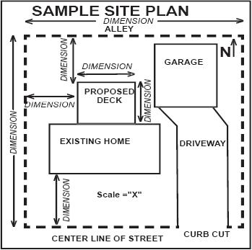
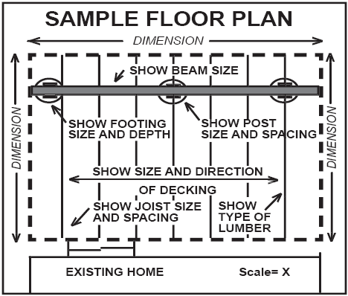 | FLOOR PLAN  - Proposed deck size.  - Size and spacing of floor joists.  - Size and type of decking material.  - Size, type, location, and spacing of posts.  - Size and type of beams.  - Beam splices must be centered over the columns.

SECTION R507 DECKS per the 2015 MN Residential Code

R507.1 Decks.
Where supported by attachment to an exterior wall, decks shall be positively anchored to the primary structure and designed for both vertical and lateral loads. Such attachment shall not be accomplished by the use of toenails or nails subject to withdrawal. Where positive connection to the primary building structure cannot be verified during inspection, decks shall be self-supporting. For decks with cantilevered framing members, connections to exterior walls or other framing members, shall be designed and constructed to resist uplift resulting from the full live load specified in Table R301.5 acting on the cantilevered portion of the deck.

R507.2 Deck ledger connection to band joists.
For decks supporting a total design load of 50 pounds per square foot (2394 Pa) [40 pounds per square foot(1915 Pa) live load plus 10 pounds per square foot (479 Pa) dead load], the connection between a deck ledger of pressure-preservative-treated Southern Pine, incised pressure-preservative-treated Hem-Fir or approved decay-resistant species and a 2-inch (51 mm) nominal lumber band joist bearing on a sill plate or wall plate shall be constructed with ½ -inch (12.7 mm) lag screws or bolts with washers in accordance with Table R507.2. Lag screws, bolts and washers shall be hot-dipped galvanized or stainless steel.

TABLE R507.2 FASTENER SPACING FOR A SOUTHERN PINE OR HEM-FIR DECK LEDGER AND A 2-INCH-NOMINAL SOLID-SAWN SPRUCE-PINE-FIR BAND JOIST ^{c,f,g} (Deck live load – 40 psf, deck dead load = 10 psf)

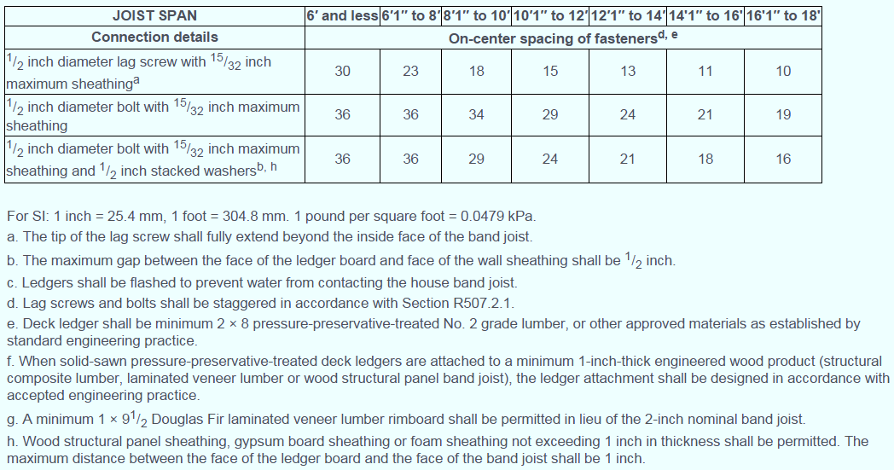

R507.2.1 Placement of lag screws or bolts in deck ledgers and band joists.
The lag screws or bolts in deck ledgers and band joists shall be placed in accordance with Table R507.2.1 and Figures R507.2.1(1) and R507.2.1(2).

TABLE 507.2.1. PLACEMENT OF LAG SCREWS AND BOLTS IN DECK LEDGERS AND BAND JOISTS
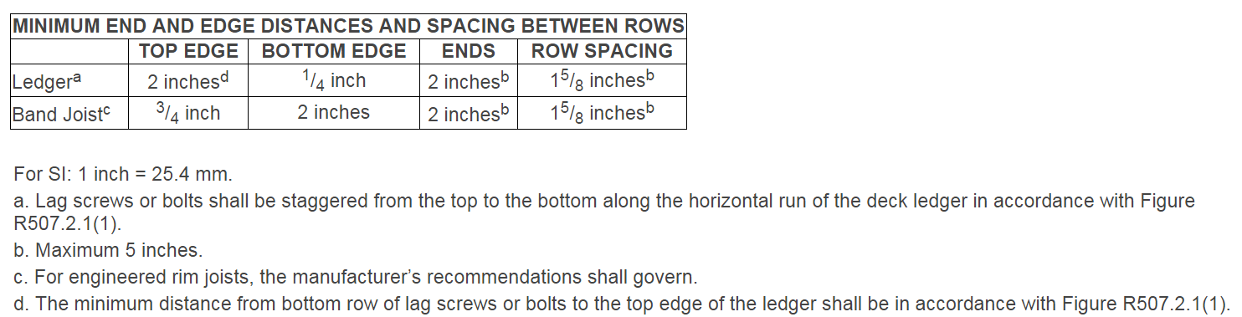
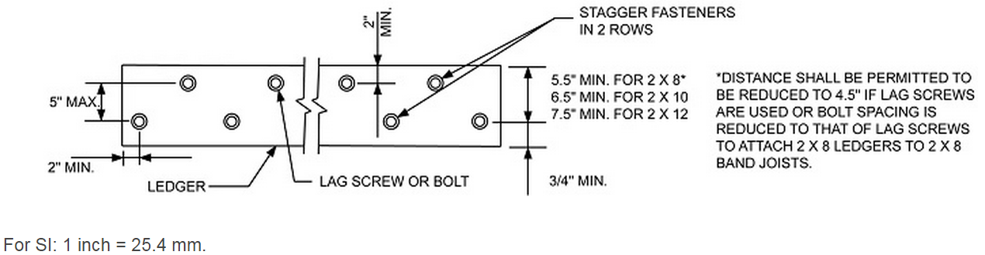

FIGURE R507.2.1(1) PLACEMENT OF LAG SCREWS AND BOLTS IN LEDGERS

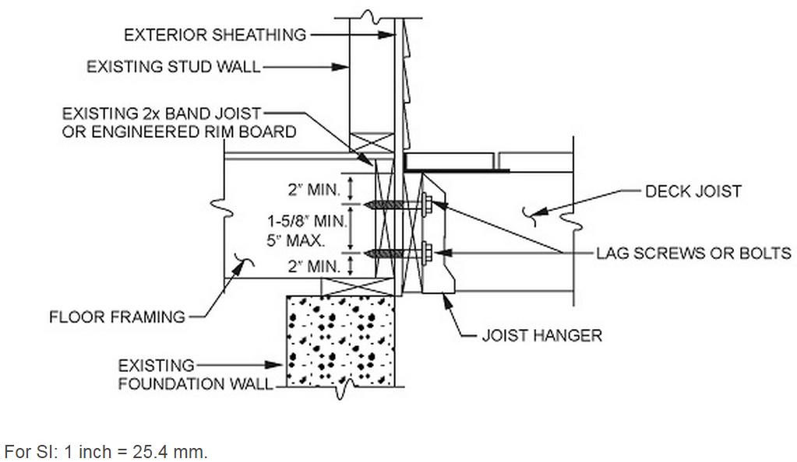

FIGURE R507.2.1(2) PLACEMENT OF LAG SCREWS AND BOLTS IN BAND JOISTS

R507.2.2 Alternate deck ledger connections.
Deck ledger connections not confirming to Table R507.2 shall be designed in accordance with accepted engineering practice. Girders supporting deck joists shall not be supported on deck ledgers or band joists. Deck ledgers shall not be supported on stone or masonry veneer.

R507.2.3 Deck lateral load connection.
The lateral load connection required by Section R507.1 shall be permitted in accordance with Figure R507.2.3. Where the lateral load connection is provided in accordance with Figure 507.2.3, hold-down tension devices shall be installed in not less than two locations per deck, and each device shall have an allowable stress design capacity of not less than 1500 pounds (6672 N).
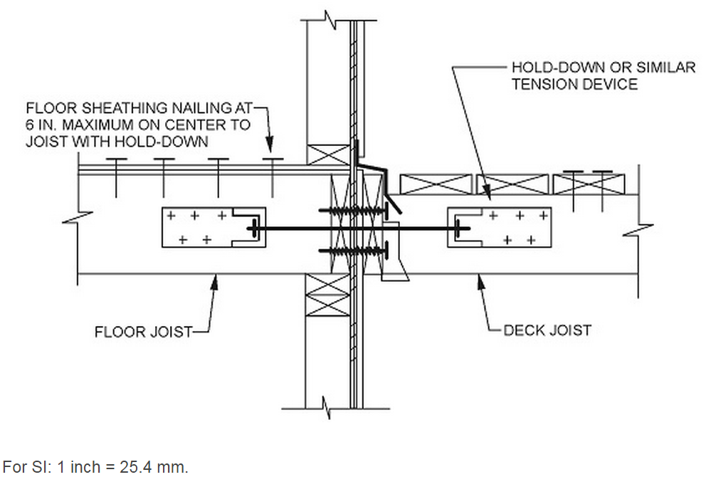

FIGURE 507.2.3 DECK ATTACHMENT FOR LATERAL LOADS

R507.3 Wood plastic composites.
Wood plastic composites used in exterior deck boards, stair treads, handrails and guardrail systems shall bear a label indicating the required performance levels and demonstrating compliance with the provisions of ASTM D 7032.

R507.3.1 Installation of wood plastic composites.
Wood plastic composites shall be installed in accordance with the manufacturer’s instructions.

